Name : Shubham Vijay Borage
Class : BCA-III (Sem-V)
Roll No. : 80
Subject : Lab on Introduction to Internet Technology

Assignment No.1

Que.1. Design a webpage which have student’s biodata with proper formatting and having student name as title.

CODE:

<!DOCTYPE html>
<html lang="en">
<head>
<title>Shubham Borage</title>
</head>
<body border="1">
<center>
<h1 style="color: brown">Student Biodata</h1>
<h3 align left style="color: blue">
</center>
Name :- Shubham Vijay Borage
</h3>
<p style="color: blue">
Class :- BCA III(B)
</p>
<p style="color: blue">
College name :- YMIM, Karad
</p>
<p style="color: blue">
<b>Date of Birth&nbsp;&nbsp;&nbsp;&nbsp;&nbsp;&nbsp;-</b>
23 june,2000
</p>
<p style="color: blue">
<b
>Address
&nbsp;&nbsp;&nbsp;&nbsp;&nbsp;&nbsp;&nbsp;&nbsp;&nbsp;&nbsp;&nbsp;&nbsp;&nbsp;- </b
>At/P-Malkapur,Tal- Karad, Dist- Satara
</p>
<p style="color: blue">
<b>Mobile No.&nbsp;&nbsp;&nbsp;&nbsp;&nbsp;&nbsp;&nbsp;&nbsp;&nbsp;-</b
>+917020463746
</p>
<p style="color: blue">
<b
>E-mail&nbsp;&nbsp;&nbsp;&nbsp;&nbsp;&nbsp;&nbsp;&nbsp;&nbsp;&nbsp;&nbsp;&nbsp;&nbsp;&nbsp;&nbsp;&nbsp;-</b
>borageshubham@gmail.com
</p>
<h3 style="color: crimson">Education Qualification-</h3>
<table border="3">
<center>
<th style="color: red">Exam</th>
<th style="color: red">Board</th>
<th style="border: red">Passing Year</th>
<th style="border: red">Institute</th>
<th style="border: red">Percentage/Pointer</th>

<tr>
<td>SSC</td>
<td>Kolhapur</td>
<td>2015</td>
<td>ACVM, Malkapur</td>
<td>73%</td>
</tr>

<tr>
<td>HSC</td>
<td>Kolhapur</td>
<td>2017</td>
<td>CJC, Satara</td>
<td>58%</td>
</tr>

<tr>
<td>BCA-II</td>
<td>BVDU,Pune</td>
<td>2021</td>
<td>YMIM, Karad</td>
<td>9.84</td>
</tr>
</center>
</table>
<p style="border: blue">
<b
>Hobbies
&nbsp;&nbsp;&nbsp;&nbsp;&nbsp;&nbsp;&nbsp;&nbsp;&nbsp;&nbsp;&nbsp;&nbsp;&nbsp;&nbsp;&nbsp;&nbsp;-</b
>
Photography,Cooking,Drawing
</p>
<p style="color: blue">
<b
>Intrested in
&nbsp;&nbsp;&nbsp;&nbsp;&nbsp;&nbsp;&nbsp;&nbsp;&nbsp;&nbsp;-</b
>HTML,CSS,JS, .Net
</p>
</body>
</html>

OUTPUT:

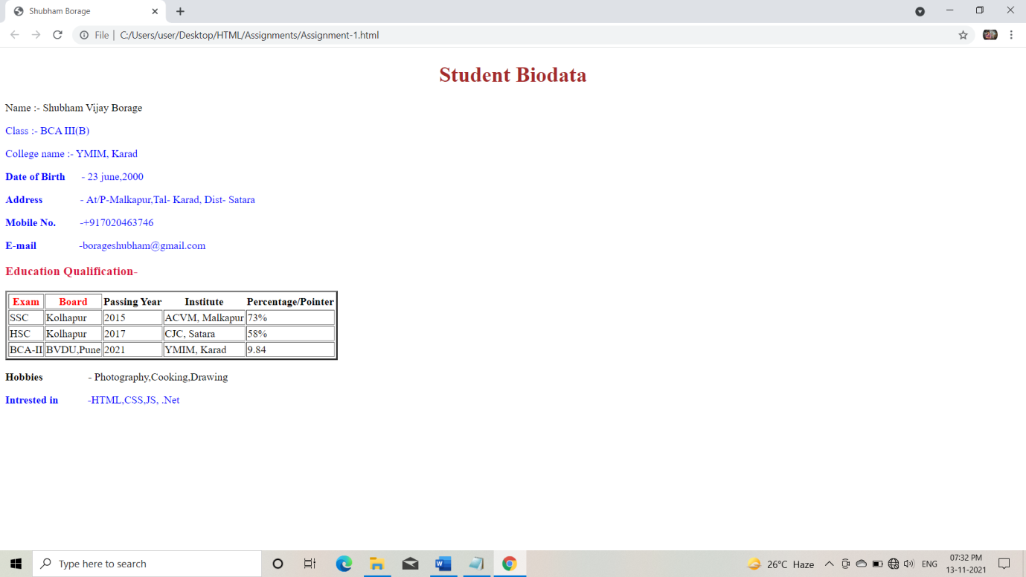

Name : Shubham Vijay Borage
Class : BCA-III (Sem-V)
Roll No. : 80
Subject : Lab on Introduction to Internet Technology

Assignment No.2

Que.2. Design a form using HTML that accepts information about your qualification, extra curricular activities, achievements, skill sets, hobbies and expectation for a particular job.

CODE:

<!DOCTYPE html>
<html lang="en">
<head>
<meta charset="UTF-8">
<meta http-equiv="X-UA-Compatible" content="IE=edge">
<meta name="viewport" content="width=device-width, initial-scale=1.0">
<title> Resume Form</title>
</head>
<body style="background-color: darkgray;">
<body style="color: floralwhite;">
<h2>Resume</h2>
<table>
<form name="myform" action="D:\Sanket Kachare HTML\html-7.html" method="GET">

<tr>
<td><label> Name</label></td>
<td><input type="text" name="fname" placeholder=" Name" required></td>
</tr>

<tr>
<td><label>Mobile Number</label></td>
<td><input type="number" name="mob" placeholder="Mobile Number" required></td>
</tr>

<tr>
<td><label>E-Mail</label></td>
<td><input type="email" name="emailadd" placeholder="E-Mail" required></td>
</tr>

<tr>
<td><label>Gender</label></td>
<td><input type="radio" name="gender" value="Male"required>Male<input type="radio" name="gender" value="Female"required>Female</td>
</tr>

<tr>
<td><label>Date of Birth</label></td>
<td><input type="date" name="dob" value="DOB" placeholder="Birth Date" required></td>
</tr>
</table>

<table>
<p>Education Qualification</p>

<tr>
<td>SSC</td>
<td><input type="text" name="Fboard" required placeholder="Board"></td>
<td><input type="number" name="Percentage" required placeholder="Percentage"></td>
<td><input type="number" name="Passing Year" required placeholder="Passing Year"></td>
</tr>

<tr>
<td>HSC</td>
<td><input type="text" name="Fboard" required placeholder="Board"></td>
<td><input type="number" name="Percentage" required placeholder="Percentage"></td>
<td><input type="number" name="Passing Year" required placeholder="Passing Year"></td>
</tr>
<tr>
<td>Graduation</td>
<td>
<select>
<option>BBA</option>
<option>BBC</option>

</select>
</td>
<td><input type="text" name="Funivetsity" required placeholder="University"></td>
<td><input type="number" name="Percentage" required placeholder="Percentage/ SGPA"></td>
<td><input type="number" name="Passing Year" required placeholder="Passing Year"></td>
</tr>
</tr>
<tr>
<td><label>Extra curricular activities </label></td>
<td><input type="text" name="Factivities" placeholder="Extra curricular activities "></td>
</tr>

<tr>
<td><label>Hobbies </label></td>
<td><input type="text" name="Fhobbies" placeholder="Hobbies "></td>
</tr>

<tr>
<td><label>Skills</label></td>
<td><input type="text" name="Fskills" placeholder="Skills " required></td>
</tr>

<tr>
<td><label>Job expectation</label></td>
<td>
<select name="Job Expectatiion">
<option>Select</option>
<option>Front End Developer</option>
<option>Back End Developer</option>
<option>Full Stack Developer</option>
<option>Web Developer</option>
<option>Application Developer</option>
</select>
</td>
</tr>
<tr>
<td><label>Photo</label></td>
<td><input type="file"required></td>
</tr>

<tr>
<td><input type="submit"></td>
<td><input type="reset"></td>
</tr>

</table>
</form>
</table>
</body>

</html>

OUTPUT:

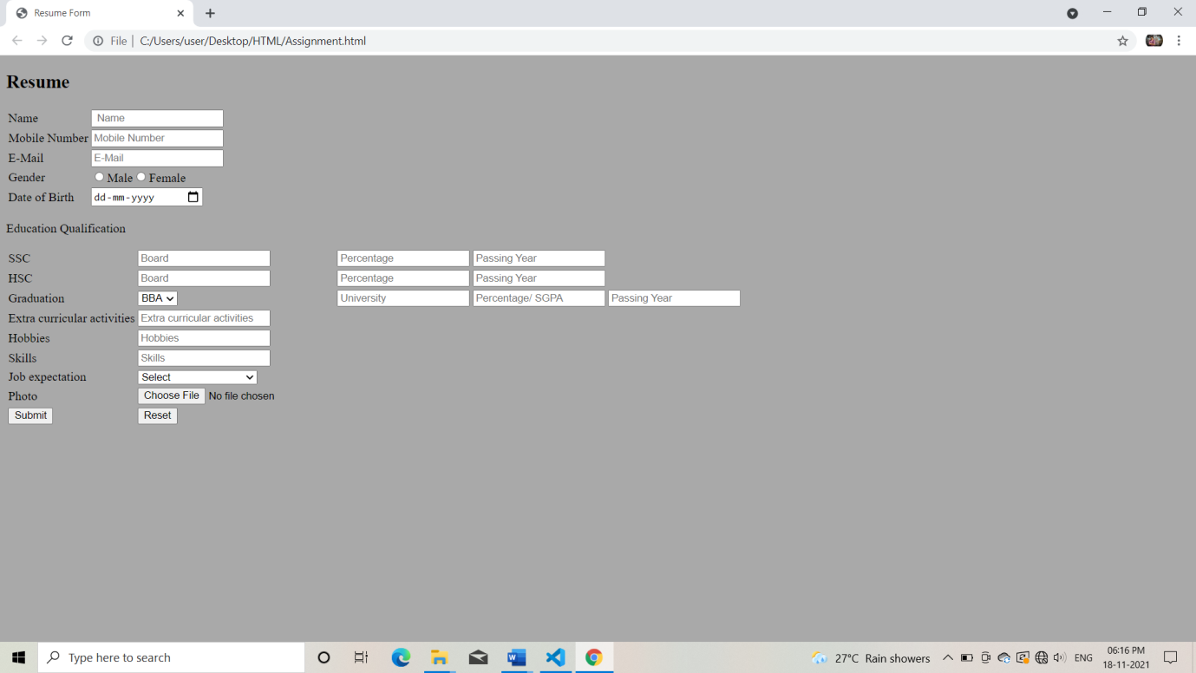

Name : Shubham Vijay Borage
Class : BCA-III (Sem-V)
Roll No. : 80
Subject : Lab on Introduction to Internet Technology

Assignment No.3

Que.3. Design a website for PNG jewelers, having images of different type of jewelries which are linked with the pages giving details about the items.

CODE:

<html>
<head>
<title>Links</title>
</head>
<body background="C:\Users\user\Desktop\HTML\PNG\Download\model-girl-beautiful-brunette-beauty-pose-smile-indian-jew-1.jpg">
<center>
<p><img src="C:\Users\user\Desktop\HTML\PNG\Download\png_logo_N1.png"><font color="Red" size="10" face="times new roman"><h1>PNG Jewellers</h1></font></p>
<p><a href="file:///C:/Users/user/Desktop/HTML/PNG/Link2.html"><font color="gold"><h2>Gold</h2></font></a></p>
<p><a href="file:///C:/Users/user/Desktop/HTML/PNG/Link3.html"><font color="gold"><h2>Diamond</h2></font></a></p>
</center>
</body>
</html>

OUTPUT:

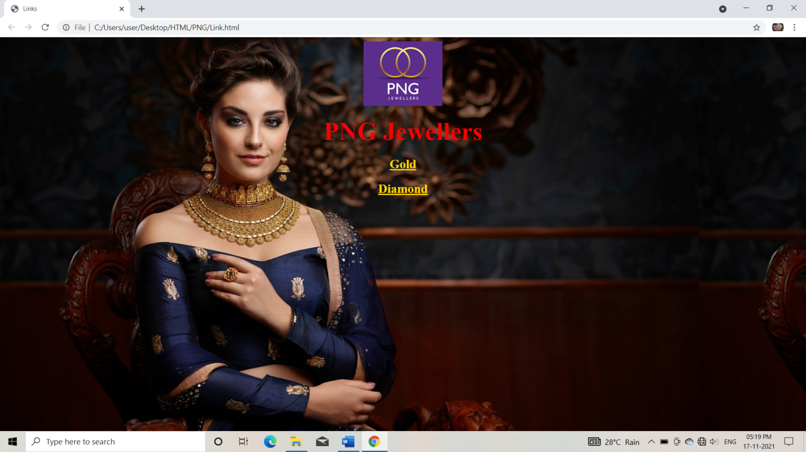
<html>
<head>
<title>Links</title>
</head>
<body background="C:\Users\user\Desktop\HTML\PNG\Download\25_free_linen_texture.jpg">
<center>
<p><img src="C:\Users\user\Desktop\HTML\PNG\Download\png_logo_N1.png"><font color="black" size="10" face="times new roman"><h1>PNG Jewellers</h1></font></p>
<p><a href="file:///C:/Users/user/Desktop/HTML/PNG/Gold%20Rings.html"><font color="Orange"><h2>Gold Rings</h2></font></a></p>
<p><a href="file:///C:/Users/user/Desktop/HTML/PNG/Gold%20Earrings.html"><font color="Orange"><h2>Gold Earrings</h2></font></a></p>
<p><a href="file:///C:/Users/user/Desktop/HTML/PNG/Gold%20Necklace.html"><font color="Orange"><h2>Gold Necklace</h2></font></a></p>
</center>
</body>
</html>

OUTPUT:

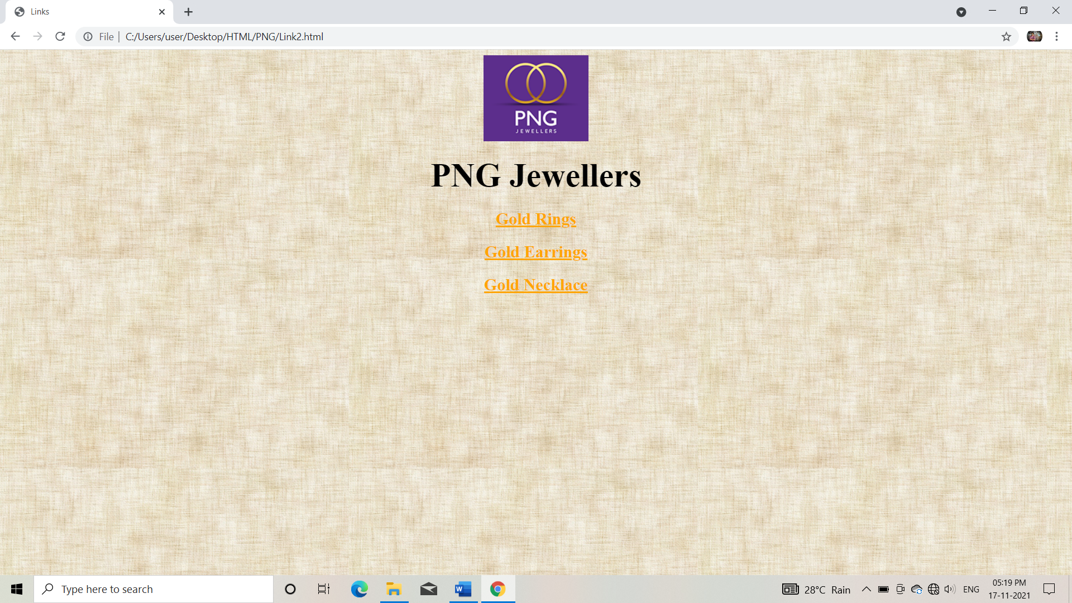

<html>
<head>
<title>
Gold Rings
</title>
<body background="">
<center>
<h1>Gold Rings for Men & Women</h1>
<table border="1">
<th><h2>Product</h2></th>
<th><h2>Price</h2></th>
<th><h2>Product</h2></th>
<th><h2>Price</h2></th>
<tr>
<td><center><imgsrc="C:\Users\user\Desktop\HTML\PNG\Download\1000976606_1.jpg" style="height: 200px;width: 200px;"></center></td>
<td><center><h3>Nargis Pure Gold Ring By PNG Jewellers</h3>
<h5>Modern and versatile daily wear ring studded with CZ in gold</h5></center>
<center>Rs. 18,718
₹ 22,461
( 12% Off )
</center>
<br>
<center><input type="button" value="Buy Now"></center>
</td>

<td><center><imgsrc="C:\Users\user\Desktop\HTML\PNG\Download\GIGR0012_1.jpg" style="height: 200px;width: 200px;"></center></td>
<td><center><h3>Marital Voyage Wedding Band For Him By PNG Jewellers</h3>
<h5>Polished Plain Gold Couple Band Ring</h5></center>
<center>Rs. 37,276
₹ 39,279
( 5% Off )
</center>
<br>
<center><input type="button" value="Buy Now"></center>
</td>

</tr>
<br>
<tr>
<td><center><imgsrc="C:\Users\user\Desktop\HTML\PNG\Download\1000976597_2.jpg" style="height: 200px;width: 200px;"></center></td>
<td><center><h3>Dhwani Pure Gold Ring By PNG Jewellers</h3>
<h5>Designer ethic wear ring studded with CZ in gold</h5></center>
<center>Rs. 16,192
₹ 18,400
( 12% Off )
</center>
<br>
<center><input type="button" value="Buy Now"></center>
</td>

<td><center><imgsrc="C:\Users\user\Desktop\HTML\PNG\Download\GIGR0009_2.jpg" style="height: 200px;width: 200px;"></center></td>
<td><center><h3>The Vow Of Love Wedding Band For Her By PNG Jewellers</h3>
<h5>Two-tone textured Gold Couple Band Ring</h5></center>
<center>Rs. 26,929
₹ 28,376
( 5% Off )
</center>
<br>
<center><input type="button" value="Buy Now"></center>
</td>

</tr>
<br>
<tr>
<td><center><imgsrc="C:\Users\user\Desktop\HTML\PNG\Download\1000976537_3.jpg" style="height: 200px;width: 200px;"></center></td>
<td><center><h3>Vidruma Pure Gold Ring By PNG Jewellers</h3>
<h5>Elegant and classy ring studded with CZ in gold</h5></center>
<center>Rs. 12,924
₹ 14,686
( 12% Off )
</center>
<br><center><input type="button" value="Buy Now"></center></td>

<td><center><imgsrc="C:\Users\user\Desktop\HTML\PNG\Download\GIGR0006_3.jpg" style="height: 200px;width: 200px;"></center></td>
<td><center><h3>The Proposal Wedding Band For Him By PNG Jewellers</h3>
<h5>Textured Plain Gold Couple Ring Band</h5></center>
<center>Rs. 37,276
₹ 39,279
( 5% Off )
</center>
<br>
<center><input type="button" value="Buy Now"></center>
</td>
</tr>
</table>
</center>
</body>
</head>
</html>
OUTPUT:

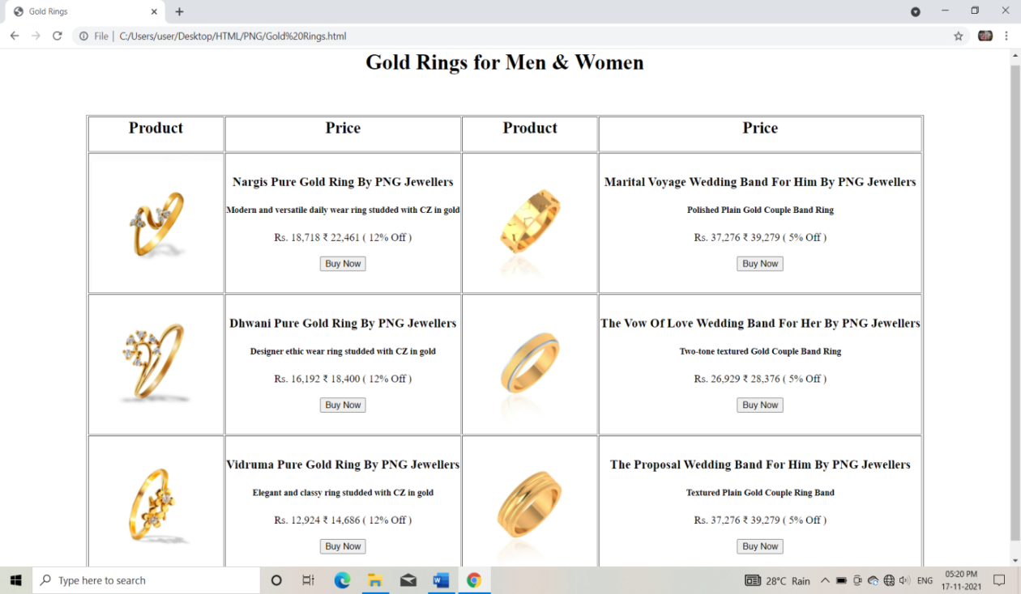
Name : Shubham Vijay Borage
Class : BCA-III (Sem-V)
Roll No. : 80
Subject : Lab on Introduction to Internet Technology

Assignment No.4

Que.4. Design a Style sheet to give following effects
The first letter of the paragraph should have 150% font size
The first line of the paragraph should have purple as background color and white as the fore color.

CODE:

<html>
<head>
<title>Assignment No.4</title>
</head>
<body>
<h3>
The first letter of the paragraph should have 150% font size:
</h3>
<p>
<font size="150%">T</font>his is demo for the font 150% size of first letter of the paragraph.
</p>
<h3>
the first line of the paragraph should have purple as background color and white as the fore color:
</h3>
<p style="background-color:purple;">
<font color="white">
Background color is purple with white color as fore color.
</font>
</p>
This is demo for formatting text size and background color.
</body>
</html>

OUTPUT:

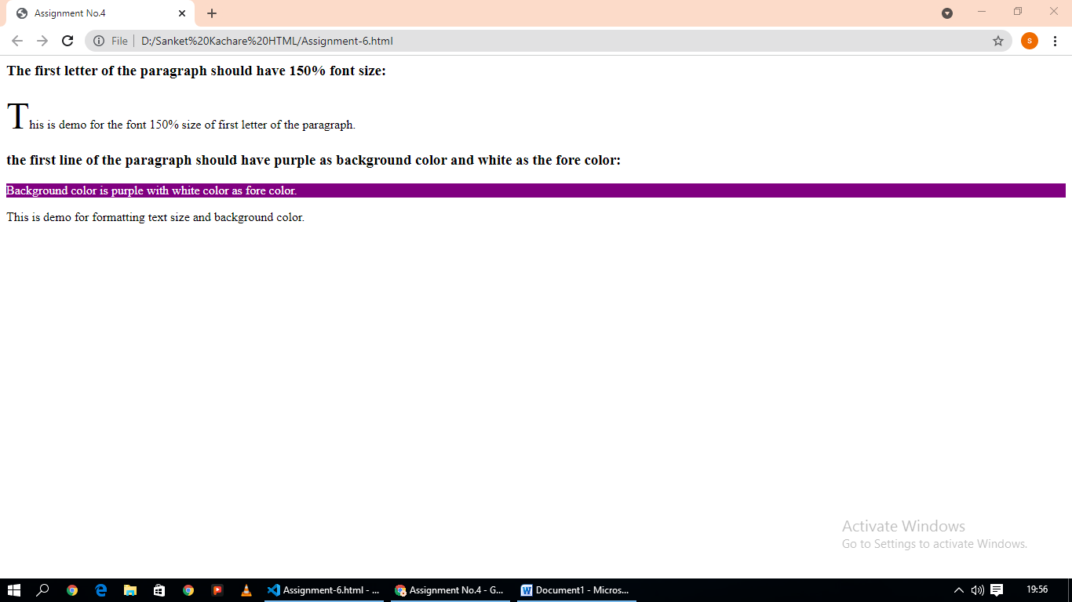

Name : Shubham Vijay Borage
Class : BCA-III (Sem-V)
Roll No. : 80
Subject : Lab on Introduction to Internet Technology

Assignment No.5

Que.4. Design a web page to display the following output
- List of subjects
- Semester III
- C++
- Dot.Net
- Semester IV
- Java
- Industrial Projects
Internet Programming
a. HTML
b. VBScript
c. Java Script
d. DHTML

CODE:

<html>

<head>
<title>Assignment6</title>
</head>

<body>
<ul type=disc>
<li>List of Subjects</li>
<br>
<ul type=square>
<li>semester III</li>
<ul type=circle>
<li>c++</li>
<li>Dot.Net</li>
</ul>
</ul>
<ul type=square>
<li>semester IV</li>
<ul type=circle>
<li>Java</li>
</ul>
<ul type=circle>
<li>Industrial Projects</li>
</ul>
</ul>
<h4><u>Internet Programming</u></h4>
<ol start="1">
<ol>
<li>HTML</li>
</ol>
</ol>
<ol>
<ol type="a" start="5">
<li>VBScript</li>
<li>JavaScript</li>
<li>DHTML</li>
</ol>
</body>

</html>

OUTPUT:

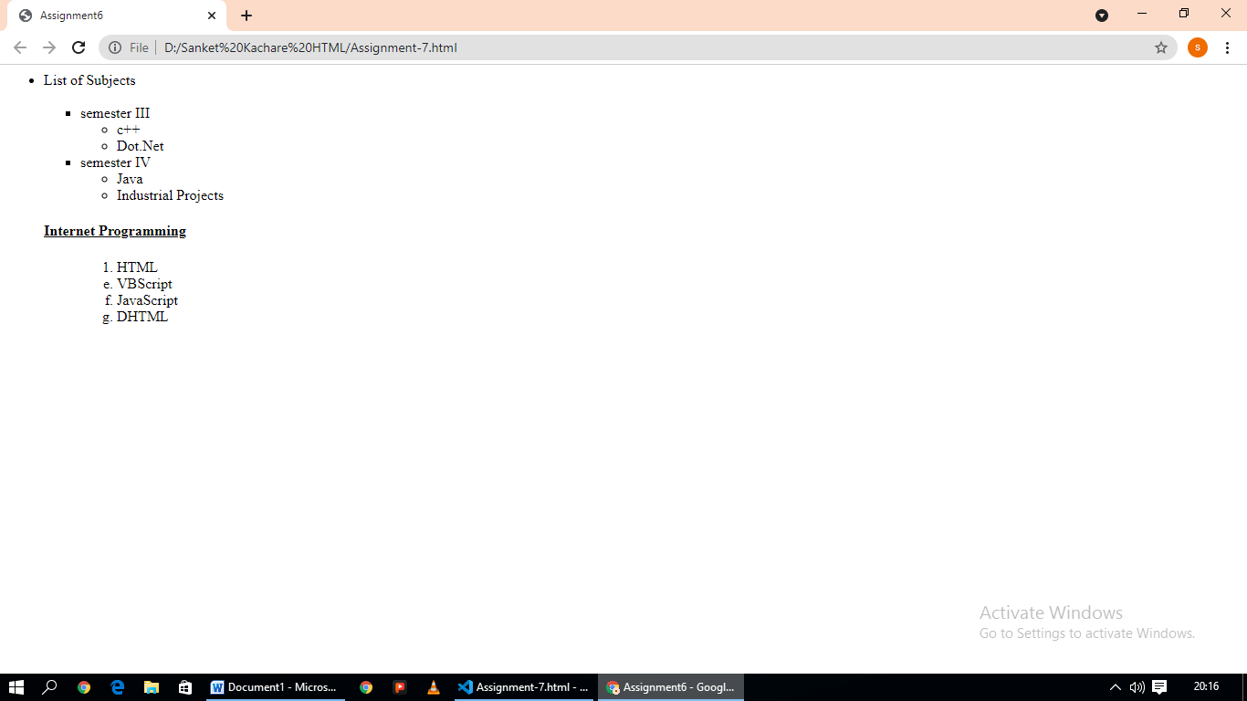

Name : Shubham Vijay Borage
Class : BCA-III (Sem-V)
Roll No. : 80
Subject : Lab on Introduction to Internet Technology

Assignment No.6

Que.6. Design a website for a class which shows student’s list linked with their biodata pages.

CODE:
<html>

<head>
<title>Anchor Tag</title>
</head>

<body bgcolor="powderblue">
<center>
<a href="file:///E:/Shubham_HTML/Programs/Biodata/Myself.html">
<h1>Myself</h1>
</a>

<a href="file:///E:/Shubham_HTML/Programs/Biodata/Akash%20Biodata.html">
<h1>Akash</h1>
</a>

<a href="file:///E:/Shubham_HTML/Programs/Biodata/Suraj%20Biodata.html">
<h1>Suraj</h1>
</a>

<a href="file:///E:/Shubham_HTML/Programs/Biodata/Sushant%20Biodata.html">
<h1>Sushant</h1>
</a>
</center>
</body>

</html>

OUTPUT:

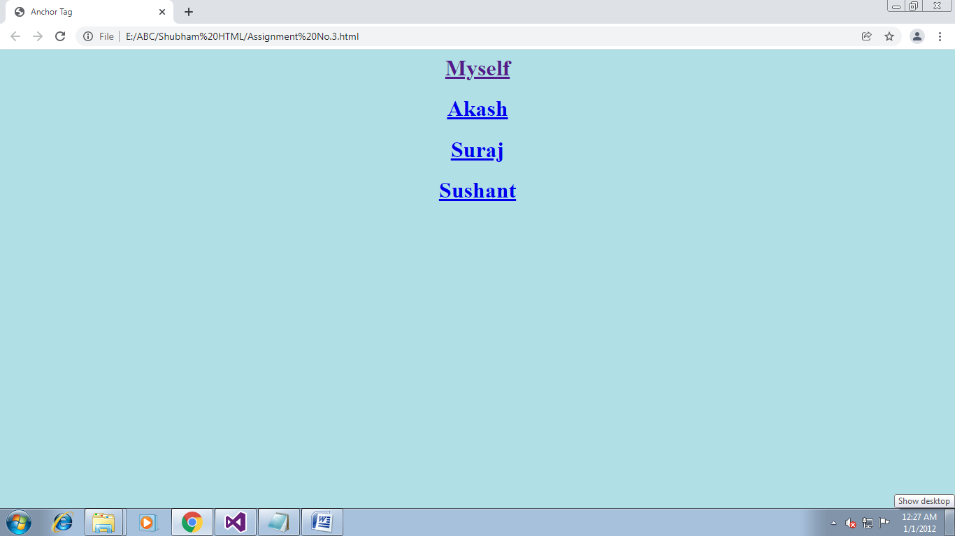

Name : Shubham Vijay Borage
Class : BCA-III (Sem-V)
Roll No. : 80
Subject : Lab on Introduction to Internet Technology

Assignment No.7

Que.7. Design a CSS(inline) that displays the regular text at the center with green as background color and white as fore color and should be bold, using class.

CODE:
<html>
<head>
<title>Assignemnt No. 5</title>
<style>
.para
{
background-size: auto;
text-align: center;
font-weight:bold;
text-size :20px;
margin-top : 10%;
}
</style>
</head>
<body>
<p class="para" style="background-color: green;color: white;">
Text at the center with green as background color, white as fore color and bold.
</p>
</body>
</html>

OUTPUT:

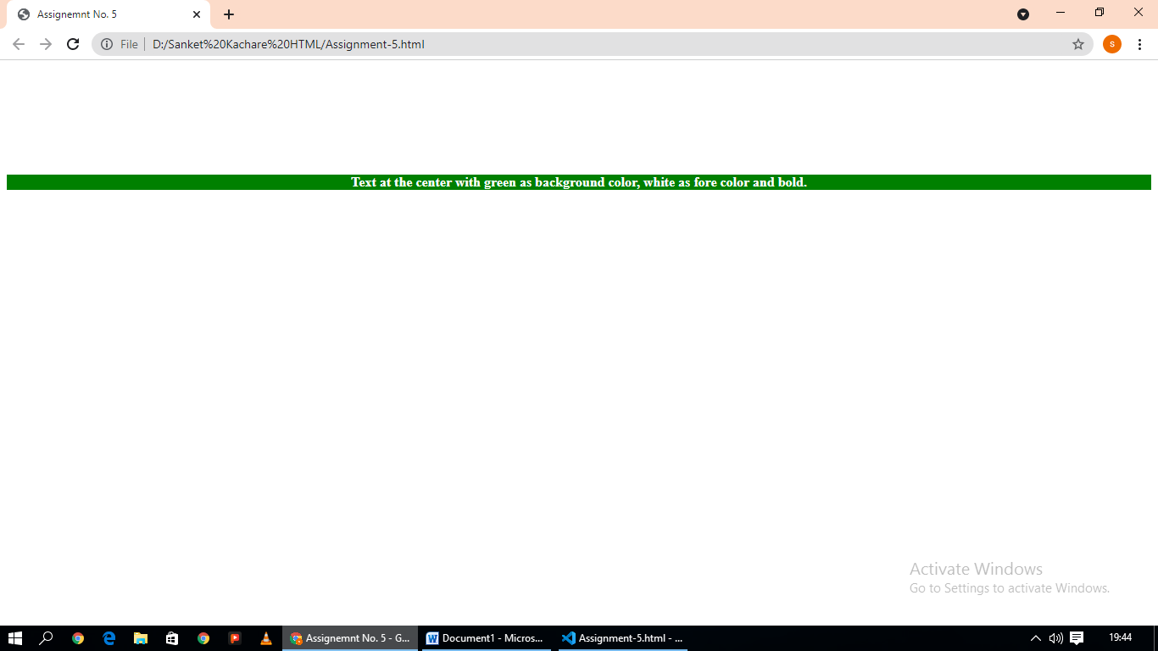

Name : Shubham Vijay Borage
Class : BCA-III (Sem-V)
Roll No. : 80
Subject : Lab on Introduction to Internet Technology

Assignment No.8

Que.8.Write a HTML code to display timetable of your class.

CODE:
<html>

<head>
<title>Assignment No. 7</title>
</head>

<body>
<table border=1px cellpadding="6" cellspacing="0" width=50% align="center">
<center>
<h3>TIME TABLE</h3>
</center>
<tr>
<th>DAY
<hr/>TIME</th>
<th>MON</th>
<th>TUE</th>
<th>WED</th>
<th>THR</th>
<th>FRI</th>
<th>SAT</th>
</tr>
<tr>
<th><pre>09:00-10:00
AM AM</pre></th>
<th>OOAD</th>
<th>OOAD</th>
<th>EC</th>
<th>GT</th>
<th>EC</th>
<th><pre>---</th>
</tr>

<tr>
<th><pre>10:00-11:00
AM AM</pre></th>
<th>C# Lab</th>
<th>C# Lec</th>
<th>C# Lab</th>
<th>IIT Lab</th>
<th>IIT Lab</th>
<th>Soft Skill</th>
</tr>
<tr>
<th><pre>11:00-11:30
AM AM</pre></th>
<thcolspan=6><pre> R E C E S S
</th>
</tr>
<tr>
<th><pre>11:30-12:30
AM PM </pre></th>
<th>C# Lec</th>
<th>IIT Lec</th>
<th>GT</th>
<th>IIT Lec</th>
<th>C# Lec</th>
<th>Webinar</tr>
</tr>
<tr>
<th><pre>12:30-1:30
PM PM</pre></th>
<th>IIT Lec</th>
<th>GT</th>
<th>OOAD</th>
<th>EC</th>
<th>GC</th>
<th>***</th>
</tr>
</table>
</body>
</html>

OUTPUT:

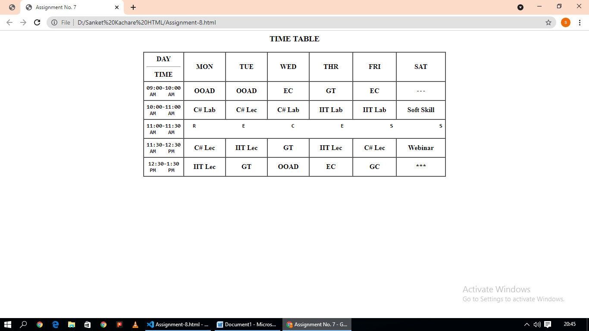

Name : Shubham Vijay Borage
Class : BCA-III (Sem-V)
Roll No. : 80
Subject : Lab on Introduction to Internet Technology

Assignment No.9

Que.9.Write a HTML code to display the mark sheet of entered seat number.

<!DOCTYPE html>
<html>
<head>
<title>Student information </title>
<script type="text/javascript">
function calc()
{
form=document.getElementById("form1");
sub1=form.sub1.value;
sub2=form.sub2.value;
sub3=form.sub3.value;
sub4=form.sub4.value;
total=parseInt(sub1)+parseInt(sub2)+parseInt(sub3)+parseInt(sub4);
form.total.value= total;
form.avg.value= parseInt(total)/4;
if(sub1<35||sub2<35||sub3<35||sub4<35)
{ form.result.value="Fail";}
else {form.result.value="Pass";}
if(form.avg.value>=80)
{form.grade.value="A";}
else if (form.avg.value>=70 &&form.avg.value<80)
{form.grade.value="B";}
else if (form.avg.value>=60 &&form.avg.value<70)
{form.grade.value="C";}
else if (form.avg.value>=50 &&form.avg.value<60)
{form.grade.value="D";}
else if (form.avg.value>=35 &&form.avg.value<50)
{form.grade.value="E";}
}
</script>
</head>
<body>
<form id="form1"><center>
<b><h1>Student information</h1></b><br />
<pre>
<b>Enter Seat No</b> :<input type="text" size="20" name="name"/><br />
<b>Marks in sub1</b> :<input type="text" size="20" name="sub1"/><br />
<b>Marks in sub2</b> :<input type="text" size="20" name="sub2"/><br />

<b>Marks in sub3</b> :<input type="text" size="20" name="sub3"/><br />
<b>Marks in sub4</b> :<input type="text" size="20" name="sub4"/><br /><br>
</pre>
<input type="button" name="btn" value="Calculate" onclick="calc()"/><br><br>
<pre>
<b>Total</b> :<input type="text" size="20" name="total" align="center" /><br />
<b>Average</b>: <input type="text" size="20" name="avg" ><br />
<b>Result</b> :<input type="text" size="20" name="result" align="center"><br />
<b>Grade</b> :<input type="text" size="20" name="grade" align="center"><br />
</pre>
<input type="reset" name="Btn2" value="Reset"/>
</center>
</form>
</body>
</html>

OUTPUT:

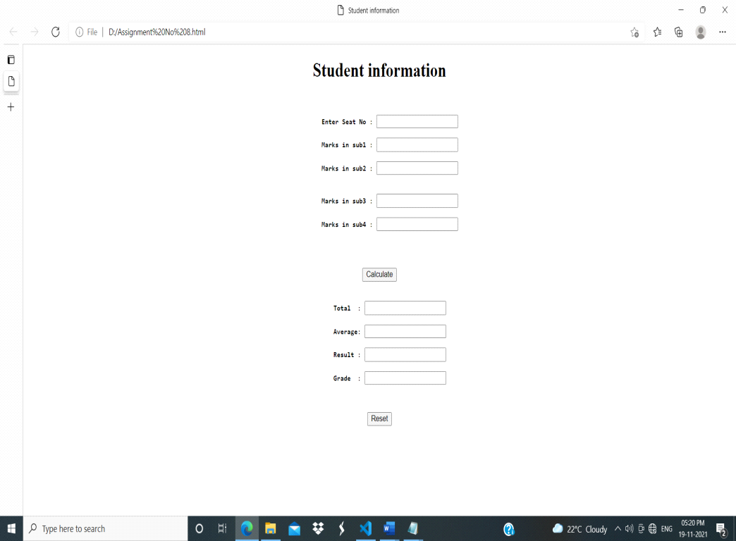

Name : Shubham Vijay Borage
Class : BCA-III (Sem-V)
Roll No. : 80
Subject : Lab on Introduction to Internet Technology

Assignment No.10

Que.10. Create a purchase order from using javascript.

<html>
<head>
<meta http-equiv="Content-Type" content="text/html; charset=iso-8859-1">
<title>Custom Calculator</title>
<style>
#myForm div{
margin-bottom:15px;
}
</style>
</head>
<body>
<form action="" method="POST" name="myForm" id="myForm">
<h1>Place your order</h1>
<div>
<label for="tiger">Tiger Plush $3</label>
<select id="tiger">
<option>0</option>
<option>1</option>
<option>2</option>
<option>3</option>
<option>4</option>
<option>5</option>
</select>
</div>
<div>
<label for="monkey">Monkey Plush $3.50</label>
<select id="monkey">
<option>0</option>
<option>1</option>
<option>2</option>
<option>3</option>
<option>4</option>
<option>5</option>
</select>
</div>
<div>
<label for="elephant">Elephant Shirt $12</label>
<select id="elephant">
<option>0</option>
<option>1</option>
<option>2</option>
<option>3</option>
<option>4</option>
<option>5</option>
</select>
</div>
<div>
<label for="penguin">Penguin Shirt $12</label>
<select id="penguin">
<option>0</option>
<option>1</option>
<option>2</option>
<option>3</option>
<option>4</option>
<option>5</option>
</select>
</div>
<h3>Cost</h3>
<div>
$<input type="text" id="cost" value="0" readonly size="3"/>
</div>

<div>
<input type="submit" />
</div>
</form>
<script type="text/javascript">
function updateTotal(){
var tot = 0;
tot += f.tiger.value * 3 +
f.monkey.value * 3.5 +
f.elephant.value * 12 +
f.penguin.value * 12;
document.getElementById("cost").value = tot.toFixed(2);
}
var f = document.forms['myForm'];
var sel = document.getElementsByTagName("select");
for(var i=0; i<sel.length; i++) {
sel[i].onchange = function(){updateTotal()};
}
f.onsubmit = function(){
alert("Your total cost will be: \\$" + f.cost.value);
return false;
}
</script>
</body>
</html>

OUTPUT:

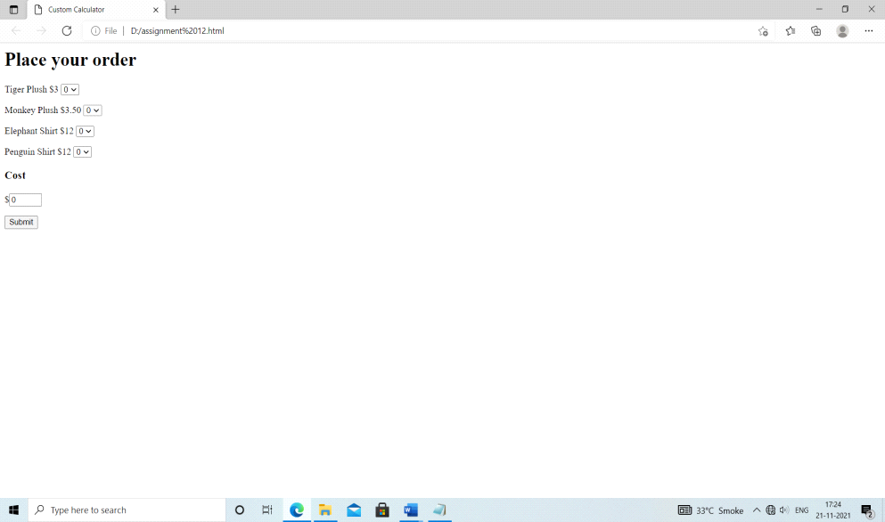

Name : Shubham Vijay Borage
Class : BCA-III (Sem-V)
Roll No. : 80
Subject : Lab on Introduction to Internet Technology

Assignment No.11

Que.11. Write Javascript that finds occurrences of letter “m” in the string entered by user in textbox and replace it with “a” and write string to page.

<!DOCTYPE html>
<html lang="en">
<head>
<meta charset="UTF-8">
<meta http-equiv="X-UA-Compatible" content="IE=edge">
<meta name="viewport" content="width=device-width, initial-scale=1.0">
<title>Sample</title>
</head>
<body>
Enter a string having letter m:
<input type="text" id="tb" name="tbb">
<br>
<input type="button" id="b" name="b" value="Replace" onclick="replacem()">
<br>
Your string with letter a instead of m:
<input type="text" id="tb1" name="tbb1">
<script>
function replacem()
{
var str=document.getElementById("tb").value;
var res=str.replace(/m/g,"a");
document.getElementById("tb1").value=res;
}
</script>
</body>
</html>

OUTPUT:

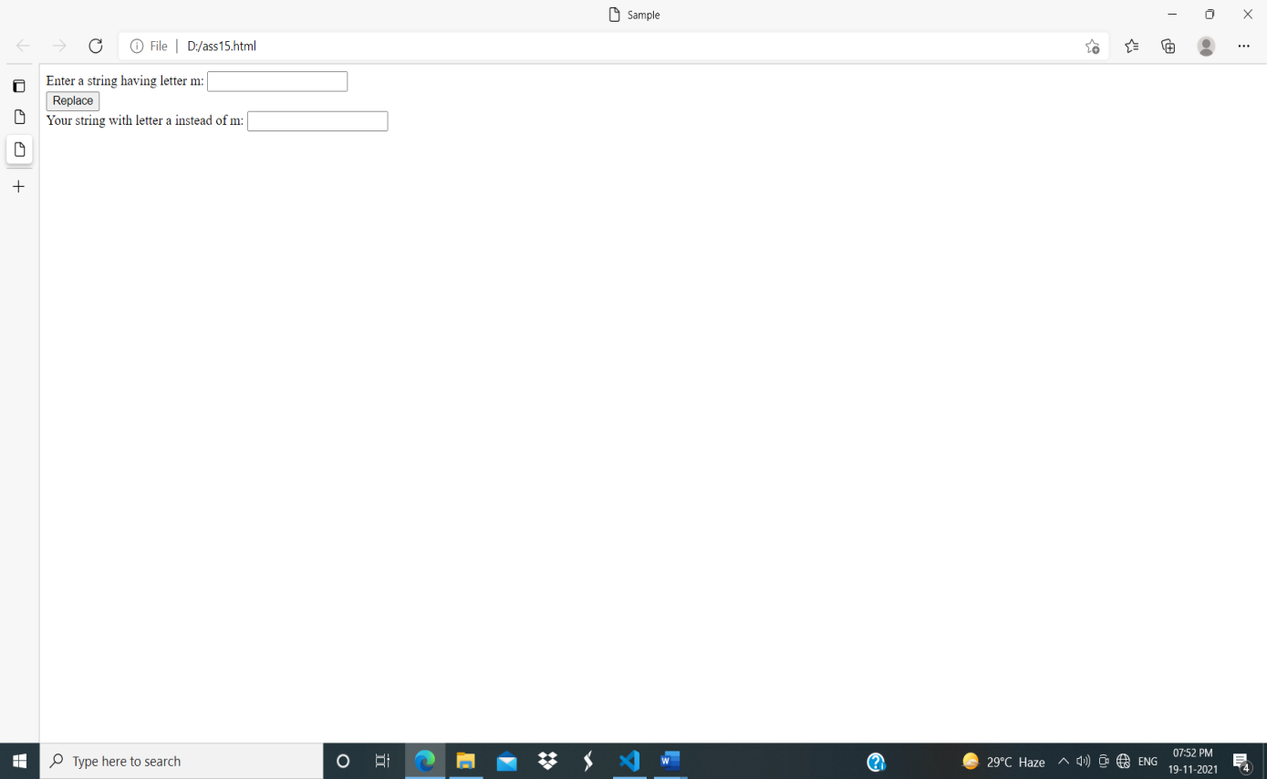

Name : Shubham Vijay Borage
Class : BCA-III (Sem-V)
Roll No. : 80
Subject : Lab on Introduction to Internet Technology

Assignment No.12

Que.11. Design a website which accepts a number from user and performs the selected operations(prime/not prime)
<!DOCTYPE html>
<html>
<head>
<title>
Check a number is Prime or not using JavaScript
</title>

<script type="text/javascript">
function p() {

var n, i, flag = true;
n = document.myform.n.value;
n = parseInt(n)
for (i = 2; i <= n - 1; i++)
if (n % i == 0) {
flag = false;
break;
}
if (flag == true)
alert(n + " is prime");
else
alert(n + " is not prime");
}
</script>
</head>

<body>
<center>

<h4>check number is prime or not</h4>

<hr color="Green">

<form name="myform">
Enter the number:
<input type="text" name=n value="">

<br><br>

<input type="button" value="Check" onClick="p()">
<br>
</form>
</center>
</body>
</html>

OUTPUT:

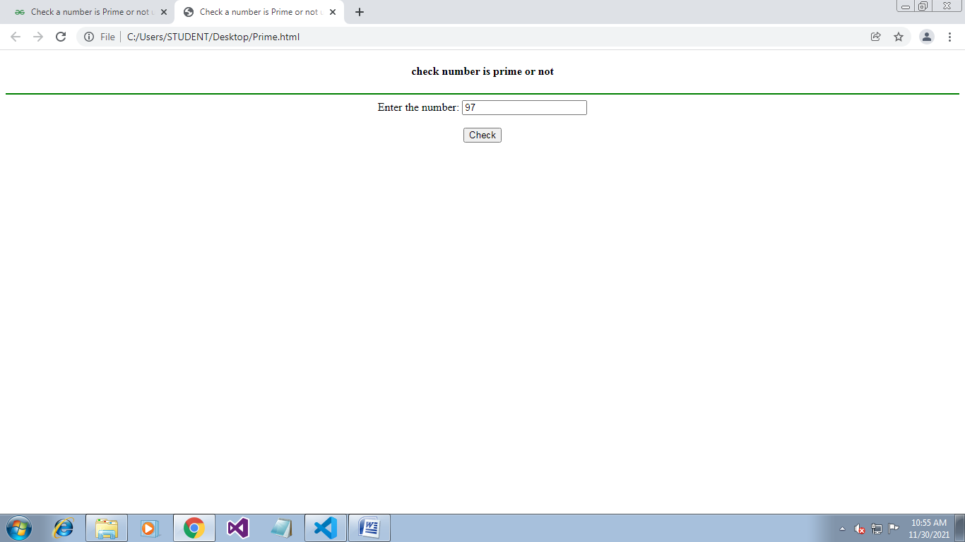

Name : Shubham Vijay Borage
Class : BCA-III (Sem-V)
Roll No. : 80
Subject : Lab on Introduction to Internet Technology

Assignment No.13

Que.11. Write a program for function to display table of entered number.
<html>
<head>
<title>JavaScript - Function to Display Table of an entered Number.</title>
<script type="text/javascript">
function printTable() {
var num;
num = Number(document.getElementById("txtNumber").value);
for (var i = 1; i <= 10; i++) {
var pTag = document.getElementById("pPrint");
pTag.innerHTML += num * i + "<br/>";
}
}
</script>
</head>

<body style="text-align: center;">
<h1>JavaScript - Function to Display Table of an entered Number.</h1>
<p><input type="text" id="txtNumber" placeholder="Enter number" /></p>
<p>
<input type="button" value="Print Table." onclick="printTable()" />
<!--print numbers-->
</p>

<p id="pPrint"></p>
</body>
</html>

OUTPUT:

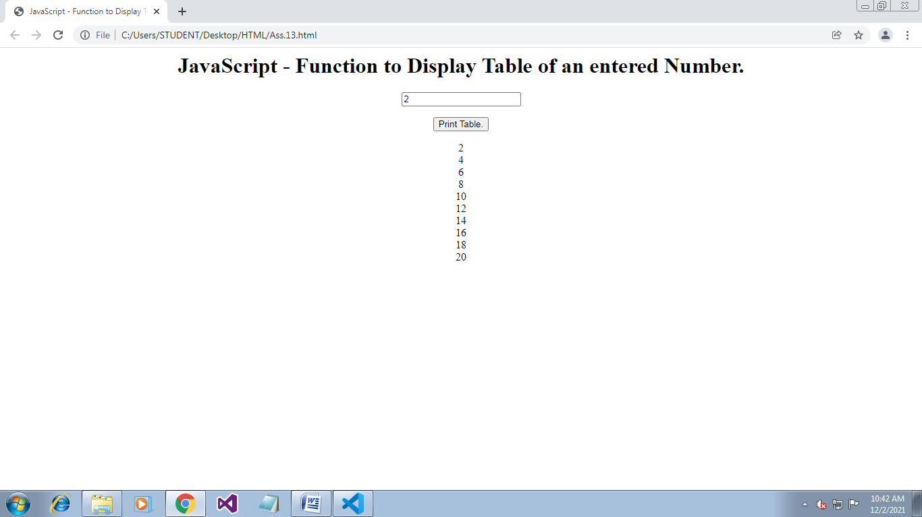

Name : Shubham Vijay Borage
Class : BCA-III (Sem-V)
Roll No. : 80
Subject : Lab on Introduction to Internet Technology

Assignment No.14

Que.11.Develop HTML form to accept mathematical expression in one textbox and display its result in another textbox after clicking on button showing mathematical operations.
<html>
<head>
<title>Mathematical Expression</title>
<script type="text/javascript">
function math_exp() {
var x = document.form1.exptext.value;
var result = eval(x);
document.form1.resulttext.value = result;
}
</script>
</head>

<body>
<center>
<form name="form1">
<table>
<tr>
<td>Expression</td>
<td><input type="text" name="exptext" /></td>
</tr>
<tr>
<td>Result</td>
<td><input type="text" name="resulttext" /></td>
</tr>
<tr>
<center>
<td><input type="button" value="calculate" onclick="math_exp()" /></td>
</center>
</tr>
</table>
</form>
</center>
</body>
</html>

OUTPUT:

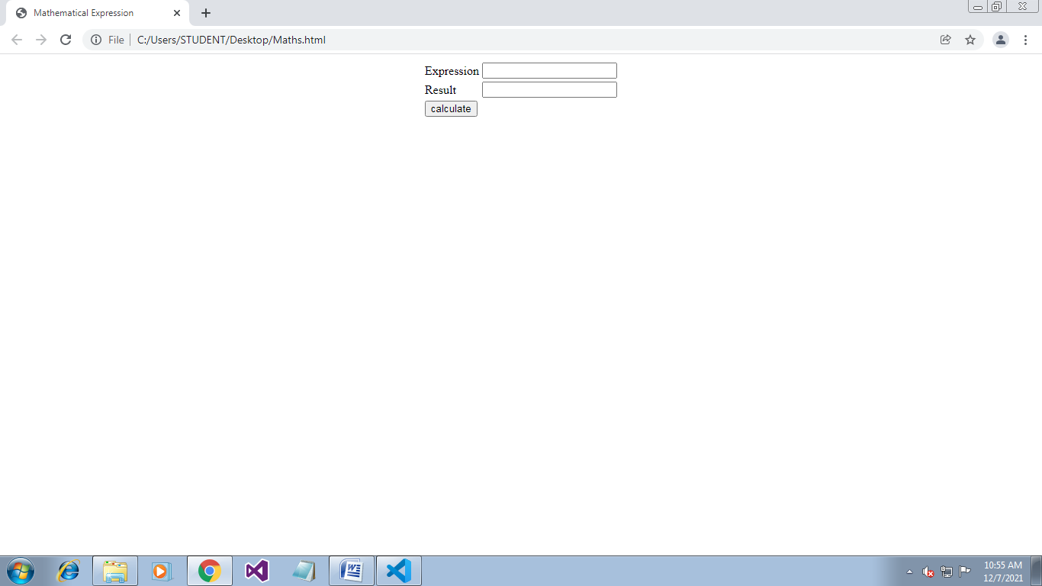

Name : Shubham Vijay Borage
Class : BCA-III (Sem-V)
Roll No. : 80
Subject : Lab on Introduction to Internet Technology

Assignment No.15

Que.11. Design a webpage which provides calculator facilities.
<html>
<head>
<script>
//function that display value
function dis(val)
{
document.getElementById("result").value+=val
}

//function that evaluates the digit and return result
function solve()
{
let x = document.getElementById("result").value
let y = eval(x)
document.getElementById("result").value = y
}

//function that clear the display
function clr()
{
document.getElementById("result").value = ""
}
</script>
<!-- for styling -->
<style>
.title{
margin-bottom: 10px;
text-align:center;
width: 210px;
color:green;
border: solid black 2px;
}

input[type="button"]
{
background-color:green;
color: black;
border: solid black 2px;
width:100%
}

input[type="text"]
{
background-color:white;
border: solid black 2px;
width:100%
}
</style>
</head>
<!-- create table -->
<body>
<div class = title >BVDU Calculator</div>
<table border="1">
<tr>
<td colspan="3"><input type="text" id="result"/></td>
<!-- clr() function will call clr to clear all value -->
<td><input type="button" value="c" onclick="clr()"/> </td>
</tr>
<tr>
<!-- create button and assign value to each button -->
<!-- dis("1") will call function dis to display value -->
<td><input type="button" value="1" onclick="dis('1')"/> </td>
<td><input type="button" value="2" onclick="dis('2')"/> </td>
<td><input type="button" value="3" onclick="dis('3')"/> </td>
<td><input type="button" value="/" onclick="dis('/')"/> </td>
</tr>
<tr>
<td><input type="button" value="4" onclick="dis('4')"/> </td>
<td><input type="button" value="5" onclick="dis('5')"/> </td>
<td><input type="button" value="6" onclick="dis('6')"/> </td>
<td><input type="button" value="-" onclick="dis('-')"/> </td>
</tr>
<tr>
<td><input type="button" value="7" onclick="dis('7')"/> </td>
<td><input type="button" value="8" onclick="dis('8')"/> </td>
<td><input type="button" value="9" onclick="dis('9')"/> </td>
<td><input type="button" value="+" onclick="dis('+')"/> </td>
</tr>
<tr>
<td><input type="button" value="." onclick="dis('.')"/> </td>
<td><input type="button" value="0" onclick="dis('0')"/> </td>
<!-- solve function call function solve to evaluate value -->
<td><input type="button" value="=" onclick="solve()"/> </td>
<td><input type="button" value="*" onclick="dis('*')"/> </td>
</tr>
</table>
</body>
</html>

OUTPUT:

